# Lesson 42 单词讲解

1. musical adj. 精通音乐的，音乐的，悦耳的

musical instrument 乐器

1. tune n. 曲调

play a tune

1. glimpse n. 一 瞥 (a quick look) have / get / catch + a glimpse of … We had a glimpse of the snake.
2. difference n. 差别

tell the difference between … and …

这里的tell表示分辨

1 musical ['mju:zikəl] a.精通音乐的

2 market ['mɑ:kit] n.市场，集市

3 snake [sneik] 玩蛇者(通常借音乐控制)

4 pipe [paip] n.(吹奏地)管乐器

5 tune [tju:n, tu:n] n.曲调

6 glimpse [glimps] n.一瞥

7 snake [sneik] n.蛇

8 movement['mu:vmənt] n.动作

9 continue[kən'tinju:] v.继续

10 dance [dɑ:ns] v.跳舞

11 obviously ['ɔbviəsli] ad.显然

12 difference ['difrəns] n.差别

13 Indian ['indiən] a.印度的

# Lesson 42 课文&语法讲解

本课重点:

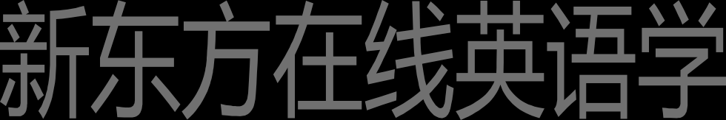复习 have 的用法实义动词

助动词

have a + n. = 对应的 v. have 的用法

实义动词

1.“有”

2.“吃喝玩乐做”

助动词（无实义，用于完成时态中）

have 的用法

实义动词 “做”

have a walk = walk

We have a walk. = We walk.

We had a walk yesterday. = We walked yesterday.

|  |  |  |
| --- | --- | --- |
| have a rest |  | rest |
| have a look |  | look |
| have a swim |  | swim |
| have a sleep  have a + n. | = | sleep  对应的 v. |

have 的用法 练习： （替换划线动词，用 have a）

1.I wanted to smoke.

= have a smoke

2.They swam in the sea this morning.

= had a swim 3.She is resting.

= is having a rest

4.He was looking at you.

= was having a look

1. As we had had a long walk through one of the markets of Old Delhi,, we stopped at a square to have a rest. had had 是 have 的过去完成时

have a walk = walk have a rest = rest

have a + n. = 对应的 v.

1. After a time, we noticed a snake charmer …, so we went to have a look at him. have a look = look

have a look at… = look at …

1. As soon as he saw us, he picked up a long pipe ... and opened one of the baskets.

I will pick you up on my way home.

He picked up some Japanese when he worked there.

1. When he began to play a tune, we had our first glimpse of the snake. 5.It rose out of the basket …

|  |  |  |
| --- | --- | --- |
| rise | rose | risen |
| rise | vi. | The sun rises every day. |
| raise | vt. | You raise me up. |

1. … when the snake charmer suddenly began to play jazz and modern pop songs. The snake, , continued to “dance” slowly.
2. The snake, however, continued to “dance” slowly.

However, The snake continued to “dance” slowly.

The snake continued to “dance” slowly, however.

have 的用法实义动词1.“有”

2.“吃喝玩乐做”

have a + n. = 对应的 v.

助动词（无实义，用于完成时态中）

当我们穿过旧德里的市场时走了很长一段路，我们在一个广场上停下来休息。过了一会儿，我们注意到广场的那一边有一个带着两个大筐的耍蛇人，于是就走过去看看。他一见我们，就拿起了一个长长的上面镶有硬币的管乐器，并掀开了一个筐的盖子。当他开始吹奏一支曲子时，我们才第一次看到那条蛇。它从筐里探出身子，随着乐器的摆动而扭动。当耍蛇人突然又吹奏起爵士乐和现代流行乐曲时，我们感到非常惊奇。然而那蛇却还是缓慢地“舞动”着。显然，它分辨不出印度音乐和爵士乐！

# Lesson 42 知识拓展

本课重点:

have 的用法实义动词 “有”

“吃喝玩乐做”

have a + n. = 对应的 v.

助动词（无实义，用于完成时态中）

have a + n. = 对应的 v.

Those two people fought in the bar last night. Those two people had a fight in the bar last night. have a + n. = 对应的 v.

I was looking at the photographs.

I was having a look at the photographs. have a + n. = 对应的 v.

Yesterday I rode on a horse for the first time in my life.

Yesterday I have a ride on a horse for the first time in my life. have 的用法

实义动词“有”

“吃喝玩乐做”

have a + n. = 对应的 v.

助动词（无实义，用于完成时态中）

